The Effects of Weather on Voter Turnout[1]

*By* Alvin Zhu

*There is a common adage amongst politicians in the United States that the Republican Party should pray for rain on Election Day. This saying addresses the prevailing belief that rain would deter more Democratic voters than Republican voters, thus giving the Republican Party an edge in voter turnout. However, by analyzing the voter turnouts of the 2012 and 2016 presidential election, I find that (i) rain actually hurts the Republicans more than the Democrats, and (ii) hotter temperatures have a more pronounced effect on voter turnout than rain. This suggests that Republicans may as well pray for hot temperatures rather than the rain.*

Election Day is perhaps the single most important day in the United States. Through the ballots of the people, citizens can decide on the entire trajectory of the country for the upcoming few years. Dominated by a two-party system of the progressive, left-leaning Democratic Party and the conservative, right-leaning Republican Party, voters choose whose view they agree with most. The elected officials, especially during the presidential election every four years, would have major influence over the American legal system, economy, and society. Therefore, it is in the best interest of any able American voter to vote during Election Day.

Yet despite the importance of elected leaders, there is an adage amongst Americans that the Republicans should pray for rain.[2] [3] This adage speaks to the idea that Democrats in particular are discouraged from voting by the rain. This may be due to the discomfort of waiting in long lines in the rain or the inconveniences brought forth by the rain, such as poor transportation. In any case, under this belief, because a greater share of Democrats choose not to vote, the Republican candidate is given a slight edge.

Yet, despite the prevalence of such an idea, few studies have actually tried to find empirical effects of rain on voter turnout. One research paper from 2007 claims that rain and snow do indeed significantly decreases the level of voter turnout in any given US county during a presidential election (Gomez, Hansford and Krause 2007). They say that every inch of rain reduces voter participation by almost 1%, whereas one inch of snow deters 0.5% of voters. At the same time, they find how rain and snow are positively correlated to the number of Republican votes. Therefore, they deduce that Republicans should pray for rain as not only would it lower the number of Democratic voters, but it would increase Republican voters. Ten years later, another study was published that refuted the earlier study over how rain and snow affected voter turnout (Horiuchi and Kang 2018). They claim how rain is not enough to justify the difference in turnout between the two political parties as it is not the rain itself that drives the Democrats away. Rather, rain induces a change in the allegiances of a voter that might convince them to vote the other way. Thus, in their argument, Republicans should still pray for the rain but not in the sense it will simply deter Democrats away from the polls.

In this paper, I will consider the effects of both temperature and precipitation on voter turnout by using a difference in differences model. I consider the difference between the 2016 Election Day average daily temperature with the five-year Election Day average daily temperature and the precipitation of a US county during 2016 Election Day to the average precipitation within the last five years. I will also account for counties that are typically dry versus rainy to gauge voter participation in response to historic weather patterns.

# Background and Data

I will be using the 2016 Voting Dataset, which consists of records for voter information by US county. I first prepared the data by calculating how many votes of each county was done inperson. If the county failed to have a 60% majority of in-person votes to non in-person votes, I disregarded the county as it would not be representative of voting behavior under weather. I then calculated the share of Democrats and Republicans against the total number of registered voters. Next, I collected data on the 2012 County Presidential Election Returns from Harvard’s Dataverse to serve as a point of comparison for the changes in weather.[4] Due to insufficient resources, I used the average maximum temperature, average minimum temperatures, and average precipitation for the last five years from the 2016 Voting Dataset to act as proxies for the historic weather patterns of a county. I combined this 2012 dataset to the 2016 dataset and proceeded to calculate the average temperature for every county during Election Day. After this cleaning process, I was left with 1346 counties out of 3110 counties for those with majority in-person votes and no missing weather data. Figure 1 shows the average temperature (in Celsius) of US counties on Election Day. Figure 2 shows the average rainfall (in millimeters) of US counties on Election Day.

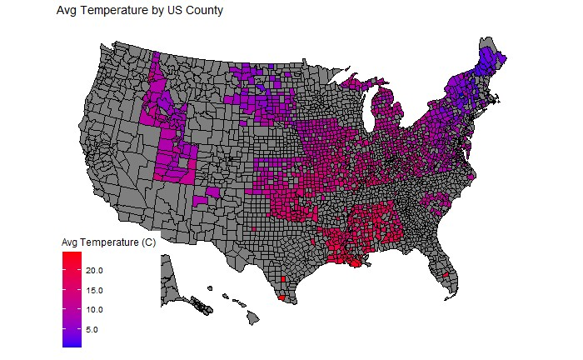

*Figure 1. Average Temperature of US Counties on 2016 Election Day*

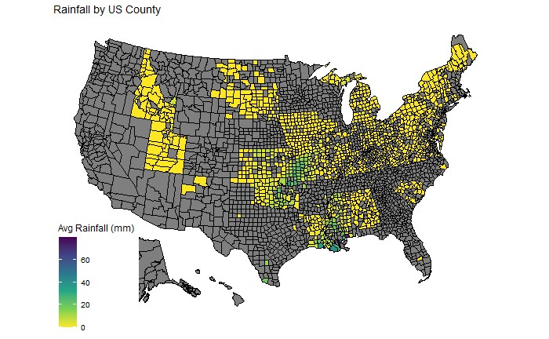

*Figure 2. Average Rainfall by US Counties on 2016 Election Day*

# Empirical Design

To isolate the effects of average daily temperature on Election Day, I first calculated the average daily temperature of a county from its daily highest and lowest temperatures. Because the average temperatures range from 0 to 30 degree Celsius, I standardize this data by calculating the difference in temperature between 2016 Election Day and Election Days of the past five years. This difference would be positive if there were hotter temperatures in 2016 than previously, and negative if temperatures were lower. This calculation would thus allow me to determine the effects of voter turnout by minute differences in temperature.

I calculated the effects of temperature and rain on voter turnout via a difference in differences method. I created a dummy variable accounting for the current presence of rain on the given Election Day for each county, and another variable accounting for the historic presence of rain on Election Day for each county. These variables would thus allow me to take into consideration the normal weather of any given county.

# Results

|  |  |  |
| --- | --- | --- |
| Estimated Effects | Democratic Votes (p-value) | Republican Votes (p-value) |
| Intercept | -0.339% (0.000) | -0.572% (0.000) |
| Change in temperature per Celsius | -0.026% (0.000) | -0.016% (0.000) |
| Change in precipitation per millimeter | -0.001% (0.393) | -0.002% (0.011) |
| Rain presence | -0.034% (0.060) | -0.082% (0.000) |
| Historic rain presence | -0.024% (0.008) | -0.102% (0.000) |
| Presence of rain in area likely to rain | -0.082% (0.000) | -0.187% (0.000) |

*Table 1. Effects of weather on the share of voter turnout for each party*

As we can see in Table 1, weather does indeed impact the share of Democratic and Republican voters for a given election. All of the estimated effects are significant except for the effects of precipitation per millimeter for the Democrats. However, contrary to popular belief, the share of Republican voters are actually more susceptible to rain than the Democrats. We see that while the share of Democratic voters decreases by 0.001% per increase in millimeter of rain, the share of Republican voters decreases by 0.002%. Even then, as mentioned, the impact of every millimeter of rain for Democratic voter turnout may not even be significant! Regardless, rain in and of itself drives away 0.34% of Democratic voters on Election Day compared to 0.082% for Republican voters. This effect, however, works in conjunction to the fact that if a county normally experiences rain, rain would not deter away as much Republican voters than Democratic voters (increase of 0.187% compared to 0.082%). This magnitude far exceeds the effects of rain per millimeter, thus giving nuance and sustenance to the adage that Republicans should pray for rain.

However, what may be more important than rain on Election Day is the temperature on Election Day. Every Celsius above the historic daily temperature of Election Day deters 0.26% of Democrats from the polls compared to 0.016% of Republicans from the polls. Not only are the magnitudes of these effects much high than that of rain, but the p-values also tell us that these effects are significant.

# Conclusions

Given the more pronounced effects of higher temperatures than that of rain, perhaps Republicans should pray for hotter temperatures as well! That way, although voter turnout for both parties decrease, the decrease in the share of Democratic votes would decrease more rapidly than Republican votes. This effect is more reliable than rain on the outcome of the number of votes casted during Election Day.

There are, of course, limitations to my study of weather on Election Day. For one, I had focused my study on two Election Days in particular: that of 2016 and 2012. These are both presidential elections and thus the found effects may not be applicable to non-presidential elections, or perhaps the effects are just smaller. Regardless, it would be extremely helpful to incorporate voter information from many other presidential elections. Note that this limitation was primarily due to the insufficient resources I had in finding and calculating the average temperature, average historic temperature, precipitation, and average historic precipitation for every county. Furthermore, some counties had a majority of votes that were not in-person while others did not have weather data altogether. These records are thus disregarded, which further limits this study.

Notwithstanding, the 2012 and 2016 presidential elections are the two most recent elections and perhaps the most representative henceforth. I showed that by taking historic weather patterns in mind, the effects of rain are more harmful to the Republicans than the Democrats. Moreover, if anything, the Republicans should be praying for hotter temperatures. Therefore, moving forward, I hope subsequent studies could find more nuance in the effects of weather on voter turnout and amass a greater literature studying the effects of weather on human choices in general.

References

AccuWeather. 2006. "AccuWeather.com Election-Day Forecast In Tightly Contested Races, Could Weather Be a Factor?" *AccuWeather.* November 3. Accessed September 30, 2020. https://www.accuweather.com/en/press/35607.

Gomez, Brad T., Thomas G. Hansford, and George A. Krause. 2007. "The Republicans Should Pray for Rain: Weather,Turnout, and Voting in U.S. Presidential Elections." *The Journal of Politics* 649-663.

Rice, Doyle. 2016. "Should Trump pray for rain on Election Day?" *USA Today*, November 6.

1. https://github.com/alvinzhu33/14.33/tree/master/14.33%20Short%20Paper
2. Rice, Doyle. 2016. "Should Trump pray for rain on Election Day?" *USA Today*, November 6.
3. AccuWeather. 2006. "AccuWeather.com Election-Day Forecast In Tightly Contested Races, Could Weather Be a Factor?" *AccuWeather.* November 3. Accessed September 30, 2020. https://www.accuweather.com/en/press/35607.
4. https://dataverse.harvard.edu/dataset.xhtml?persistentId=doi:10.7910/DVN/VOQCHQ